ICS 23.020.30
CCS J 74

National Standard of the People's Republic of China

GB/T 42610-2023

Test Method for Evaluating Hydrogen Compatibility of Plastic Liner of High Pressure Gaseous Hydrogen Cylinders

Promulgated on XX-XX-XXXX Implemented on XX-XX-XXXX
Promulgated by
General Administration of Quality Supervision, Inspection and Quarantine of the People's Republic of China
Standardization Administration of the People's Republic of China

Contents
Foreword II
1 Scope 1
2 Normative References 1
3 Terms, Definitions, and Symbols 2
4 General requirements 2
5 Test Conditions 3
6 Test Methods 4
7 Test Report 12
Annex A (Informative) Basic Structure of Main Body of Hydrogen Permeation Test Device 14

Foreword
This standard is drafted in accordance with the rules given in the GB/T 1.1-2020 Directives for Standardization - Part 1: Rules for the Structure and Drafting of Standardizing Documents.
This standard has been redrafted and modified adoption of international Standard ISO 11114-5:2022 Gas cylinders - Compatibility of cylinder and valve materials with gas contents - Part 5:Test methods for evaluating plastic liners.
Attention is drawn to the possibility that some of the elements of this standard may be the subject of patent rights. The issuing body of this standard shall not be held responsible for identifying any or all patent rights.
This standard was proposed and prepared by SAT/TC 31 (National Technical Committee 31 on Cylinder of Standardization Administration of China ).
SAC/TC 31 is in charge of this English translation. In case of any doubt about the contents of English translation, the Chinese original shall be considered authoritative.
Drafting units of this Document:
Main drafters of this Document:
It is the first release of this Document.

Test Method for Evaluating Hydrogen Compatibility of Plastic Liner of High Pressure Gaseous Hydrogen Cylinders
1 Scope
This standard specifies the terms and definitions, general requirements, test conditions, test methods and test reports concerning the hydrogen compatibility test for the plastic liner of high pressure gaseous hydrogen cylinders.
This standard is applicable to the evaluation on hydrogen compatibility of plastic liner for the high pressure gaseous hydrogen cylinder featuring a nominal working pressure of not more than 70 MPa, a storage medium of compressed hydrogen, a test temperature of not lower than -40°C but not higher than 85°C.
2 Normative References
The following referenced documents are indispensable for the application of this document. For dated references, only the edition cited applies. For undated references, the latest edition of the referenced document (including any amendments) applies.

GB/T 1033.1 Plastics — Methods for Determining the Density of Non-celluar Plastics - Part1: Immersion Method, Liquid Pyknometer Method and Titration Method
GB/T 1040.1 Plastics — Determination of Tensile Properties — Part 1: General Principles
GB/T 1040.2 Plastics — Determination of Tensile Properties — Part 2: Test Conditions for Moulding and Extrusion Plastics
GB/T 5163 Sintered Metal Materials, Excluding Hardmetals — Permeable Sintered Metal Materials — Determination of Density, Oil Content, and Open Porosity
GB/T 5330.1 Industrial Wire Screens and Woven Wire Cloth — Guide to the Choice of Aperture Size and Wire Diameter Combinations — Part 1: Generalities
GB/T 5832.1 Gas Analysis — Determination of Moisture — Part 1;Electrolytic Method
GB/T 5832.2 Gas Analysis — Determination of Moisture — Part 2;Dew Point Method
GB/T 6285 Determination of Trace Oxygen in Gases — Electrochemical Method
GB/T 13005 Terminology of Gas Cylinders
GB/T 28726 Gas Analysis — Gas Chromatograph with Helium Ionization Detector
GB/T 29729 Essential requirements for the Safety of Hydrogen Systems
GB/T 34542.1 Storage and Transportation Systems for Gaseous Hydrogen — Part 1: General Requirements
GB/T 37244 Fuel Specification for Proton Exchange Membrane Fuel Cell Vehicles — Hydrogen
3 Terms, Definitions, and Symbols
3.1 Terms and definitions
For the purposes of this document, the terms and definitions given in GB/T 13005 and the following apply.
3.1.1 plastic liner
An inner plastic shell which, in contact with the gas filled and wrapped with a carbon fiber reinforcement layer on its outer surface, is designed for gas sealing and not for pressure load bearing.
3.1.2 seamless liner
A plastic liner molded in one piece and having no spliced welds.
3.1.3 welded liner
A plastic liner with spliced welds.
3.1.4 blister
A localized bubble-like defect in polymer.
3.1.5 nominal working pressure (P)
The limited filling pressure of a cylinder under the reference temperature (15°C).
3.2 Symbols
The following symbols apply to this Document.
B Thickness of disc sample (m);
P_{e}, Gas permeability coefficient of material (mol.m/(m².s.Pa));
S Surface area of the sample exposed to hydrogen during the permeation test (m²);
P Pressure difference between high-pressure side and low-pressure side of the sample during the penetration test (Pa);
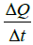 Gas transmission rate during steady permeation (mol/s).
4 General requirements
4.1 The tests of hydrogen compatibility of plastic liner for high pressure gaseous hydrogen cylinder involve plastic liner material test and cylinder liner test. The plastic liner material test includes hydrogen permeation test, physical property test, mechanical property test(tensile property test), hydrogen initial cycling test and hydrogen extended aging test; the cylinder liner test includes extreme temperature cycling test, liner collapse and blister test. The test procedure is as shown in Figure 1.
4.2 The hydrogen compatibility test apparatus shall be designed, installed and managed as specified in GB/T 29729 and GB/T 34542.1.
4.3 The test apparatus should be free from impurities that could interact with the sample under test or contaminate the hydrogen test gas.
5 Test Conditions
5.1 Gas source
5.1.1 The composition of hydrogen used in the test shall conform to the requirements on quality of hydrogen for fuel cell vehicles as specified in GB/T 37244.
5.1.2 The purity of nitrogen or inert gas used for replacement shall be greater than or equal to 99.999%.
5.2 Replacement
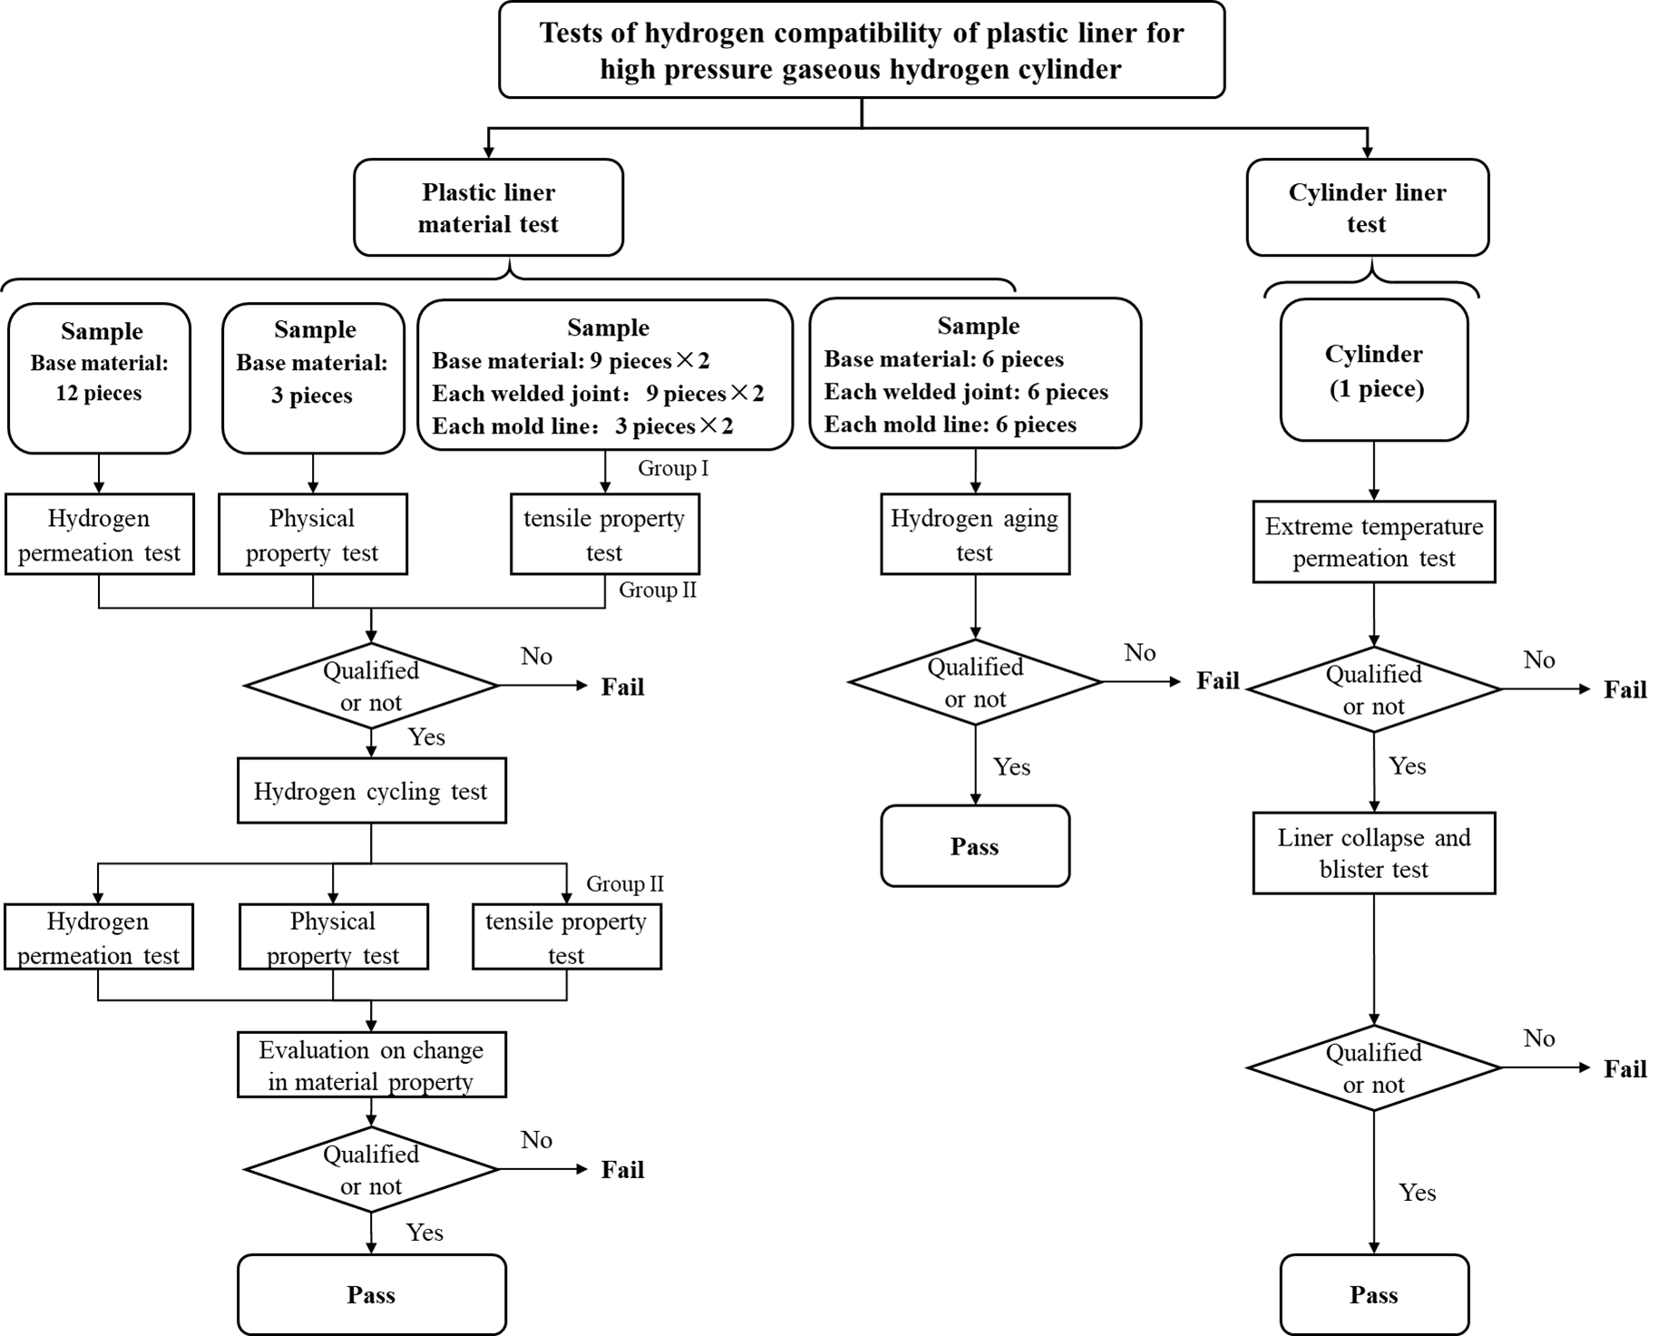
Figure 1 Procedure for tests of hydrogen compatibility of plastic liner for high pressure gaseous hydrogen cylinder
5.2.1 Prior to the test, the test system and hydrogen supply pipeline system shall be replaced with nitrogen or inert gas, and then with hydrogen. The volume of oxygen in the test system shall be tested before the introduction of hydrogen, which shall not exceed 1%. Upon completion of the replacement, the volume of oxygen in the test system should be less than or equal to 1×10⁻⁶, and the volume of water should be less than or equal to 5×10⁻⁶.
5.2.2 Oxygen content should be tested as specified in GB/T 28726 or GB/T 6285, water content should be tested as specified in GB/T 5832.1 or GB/T 5832.2.
5.2.3 When the hydrogen, replacement gas and replacement procedure used for the test comply with the provisions of 5.1.1, 5.1.2 and 5.2.1 respectively, and when the oxygen and water content in the test system meet the requirements of 5.2.1 in three consecutive tests, it is not necessary to detect the oxygen and water content in the test system within 6 months.
6 Test Methods
6.1 Plastic liner material test
6.1.1 General requirements
6.1.1.1 The base material test shall be carried out for the seamless plastic liner, and the base material test and welded joint test shall be carried out for the welded plastic liner.
6.1.1.2 The samples for plastic liner material test shall be taken from two circumferential sections of the same liner. Take 4 hydrogen permeation samples and 1 physical property sample at an interval of 120° along the circumferential direction of one section. Take 6 tensile property samples, and 2 hydrogen aging samples at an interval of 120° along the circumferential direction of the other section, as shown in Figure 2:
a) Seamless plastic liner: the sections for sampling fall in the middle of the barrel while the section spacing shall be greater than 200 mm;
b) Welded plastic liner: when there is one circumferential welded joint, take samples from the middle between the two ends of the cylinder and the welded joints; when there are two circumferential welded joints, take samples from the middle of the cylinder, and the cross-sectional spacing should be greater than 200 mm.
6.1.1.3 For welded plastic liners, take 6 tensile properties samples and 2 hydrogen aging samples at an interval of 120° along the circumferential direction at each welding joint. For blow molded liners with parting lines, take 6 tensile performance samples and 2 hydrogen aging samples at the mold line, and the sampling locations are shown in Figure 2. When sampling, ensure that the weld or parting line is in the middle of the sample.
6.1.1.4 The sample surface shall be free of wrinkles, creases, inclusions, porosity or other defects.
6.1.1.5 The samples shall be stored properly in a dry environment.
Figure 2 Sampling site for plastic liner material test
6.1.2 Hydrogen permeation test
6.1.2.1 Sample
6.1.2.1.1 The disc sample with a diameter of (78±1) mm should be used. The diameter of the contact area between the sample and hydrogen shall be greater than or equal to 25 mm, while the thickness of the sample is taken as the thickness of the inner tank.
6.1.2.1.2 For the same liner material, 12 hydrogen permeation test samples shall be prepared, divided into three groups, 4 samples in each group.
6.1.2.1.3 Prior to the test, the disc sample shall be placed in a vacuum drying oven, where the absolute pressure is 1,000 Pa~5,000 Pa and the temperature is 65°C, until the mass loss of the sample is less than 0.1% within 24h.
6.1.2.2 Test device
6.1.2.2.1 See Annex A for the basic structure of the main body of the hydrogen permeation test device.
6.1.2.2.2 The mesh size of the wire-mesh screen should be less than or equal to 0.15 mm, the percentage of sieve area should be greater than or equal to 35%, and the wire diameter should be selected as specified in GB/T 5330.1.
6.1.2.2.3 The opening porosity of sintered metal support should be greater than or equal to 40% and it should be calibrated as specified in GB/T 5163 before the test.
6.1.2.2.4 The sealing ring should be replaced every time the hydrogen permeation test is carried out.
6.1.2.2.5 The control accuracy of the temperature control device shall not be lower than ± 1°C; the control accuracy of the pressure control device shall not be lower than ±1% of the test pressure.
6.1.2.3 Test procedure
6.1.2.3.1 Prior to the test, the cavity on the high pressure side of the sample shall be replaced according to the recommendations given in 5.2.1.
6.1.2.3.2 Perform the hydrogen permeation test under the following temperature and pressure conditions for each of the 4 groups of samples:
a) (55 ± 1) °C, 1.15 times the nominal working pressure of the cylinder;
b) (15 ± 1) °C, 1.0 times the nominal working pressure of the cylinder;
c) (55 ± 1) °C, 0.1 times the nominal working pressure of the cylinder;
d) (15 ± 1) °C, 0.1 times the nominal working pressure of the cylinder.
6.1.2.3.3 At the specified test temperature, pressurize the high pressure side of the sample to the specified test pressure. After the temperature and pressure on the high pressure side are stabilized, measure the hydrogen transmission rate on the low pressure side of the sample. Sampling should be performed at least once every 10 min in the non-steady state phase, and at least once every 30 min in the steady state phase, until the maximum deviation of the hydrogen transmission rate is less than or equal to ±1% over a period of more than 24 h. Record the hydrogen transmission rate on the low-pressure side versus time, as shown in Figure 3.
6.1.2.3.4 Methods for measuring the hydrogen transmission rate on the low-pressure side including (but not limited to):
a) Measure the change of hydrogen concentration on the low-pressure side;
b) Measuring gas pressure changes on the low-pressure side;
c) Measure the gas volume change on the low-pressure side;
d) Adopt other equivalent methods.
6.1.2.3.5 At the completion of the test, the pressure release rate on the high-pressure side of the sample should not be less than 1.2 times the maximum hydrogen release rate of the cylinder during actual use.
6.1.2.3.7 Following the completion of the test, the sample surface shall be inspected and recorded for the presence of blister or other defectsThe quality of the sample should be measured and recorded respectively before the test and 48 h after the test.
6.1.2.3.7 Each group of samples shall be subjected to the hydrogen permeation test respectively before the hydrogen cycle test and 48 hours after the hydrogen cycle test according to the test procedure shown in Figure 1.
6.1.2.3.8 Calculate the hydrogen permeability coefficient according to Formula (1).
………………………………（1）
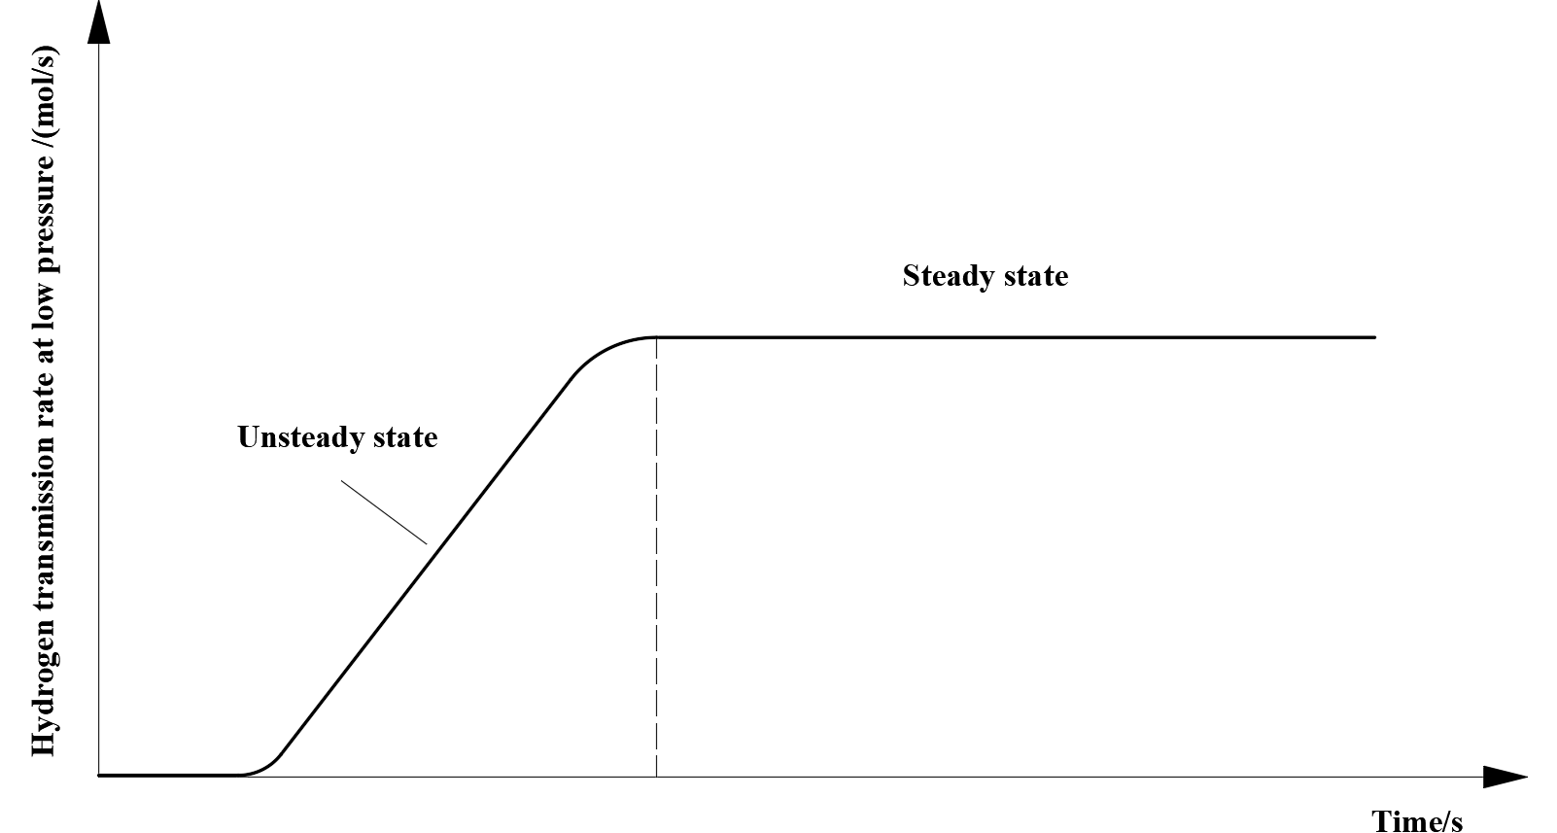
Figure 3 Example curve of hydrogen transmission rate versus time on the low- pressure side
6.1.3 Physical property test
6.1.3.1 Sample
6.1.3.1.1 The long-strip sample with a length of (40 ± 0.2) mm, a width of (10 ± 0.2) mm and a thickness of (4 ± 0.2) mm should be used. When the thickness of the liner is less than 4 mm, the thickness of the sample should be equal to that of the liner.
6.1.3.1.2 For the same liner material, at least 3 samples shall be prepared for the physical property test.
6.1.3.2 Test device
6.1.3.2.1 The density measuring instrument shall conform to the relevant provisions of Method A in GB/T 1033.1.
6.1.3.2.2 For the sample with a mass of 1 g~5 g, the measured value shall be accurate to 0.1 mg; for the sample with a mass greater than 5 g, the measured value shall be accurate to 1 mg.
6.1.3.2.3 The dimension measuring equipment shall have an accuracy of not less than 0.0025 mm.
6.1.3.3 Test method
6.1.3.3.1 Measure the sample mass, density and volume according to the following steps:
a) Record appearance images of the sample by using a digital camera;
b) Measure dry mass of the sample by using an analytical balance;
c) Weigh the total mass of the impregnation vessel and impregnation solution by using an analytical balance, and weigh the mass of the suspension wire and settling block separately;
d) Immerse the sample in the impregnation solution, remove the air bubbles on the sample surface and weigh the sample, where the sample shall not be in contact with wall of the impregnation vessel;
e) Dry surface of the sample taken out;
f) Calculate density and volume of the sample as specified in GB/T 1033.1.
6.1.3.3.2 Measure dimensions of the sample by using a tool microscope or other appropriate measuring instrument.
6.1.3.3.3 Measure, prior to the hydrogen cycling test, within 10 min upon completion of the test, 24 h later upon completion of the test and 48 h later upon completion of the test, dimensions, volume, mass and density of the sample, respectively, as well as record apparent images of the sample.
6.1.3.4 Acceptance indicators
48 h later upon completion of the hydrogen cycling test, the sample mass change rate is less than or equal to 0.75%, its density change rate is less than or equal to 0.75%, and its volume change rate is less than or equal to 10%.
6.1.4 Mechanical property test
6.1.4.1 Sample
6.1.4.1.1 The sample shape and dimensions shall conform to the provisions of GB/T 1040.2.
6.1.4.1.2 For the same liner material, 18 samples shall be prepared for the mechanical property test, divided into 2 groups, 9 for each group.
6.1.4.2 Test device
The test device shall conform to the provisions of GB/T 1040.1, GB/T 1040.2 and relevant national standards.
6.1.4.3 Test method
The mechanical property test for the plastic liner material shall conform to the provisions of GB/T 1040.1, GB/T 1040.2 and relevant national standards. The test shall be performed according to the following steps:
a) Prior to the hydrogen cycling test, perform the tensile test for the first group of samples at room temperature, -50 °C and 90 °C (3 samples for each temperature), respectively, and then record the tensile curve;
b) Complete the hydrogen cycling test with the second group of samples, and perform, 48 h later upon completion of the hydrogen cycling test, the tensile test at room temperature, -50 °C and 90 °C (3 samples for each temperature), and then record the tensile curve;
c) Evaluate the material mechanical property of the sample.
6.1.4.4 Acceptance indicators
The sample suffers a ductile fracture, where the tensile strength and nominal strain of tensile fracture meet requirements of the design documentation. Under the same test temperature, the average tensile strength of the material before and after the hydrogen cycling test shall not change by more than 20%, and the average nominal strain of tensile fracture shall not change by more than 20%.
6.1.5 Hydrogen cycling test
6.1.5.1 Sample
The samples for hydrogen cycling test shall include:
a) The 12 samples that have undergone the first hydrogen permeation test in 6.1.2;
b) The 3 samples that have undergone the first physical property test in 6.1.3;
c) The second group of samples in 6.1.4 .
6.1.5.2 Test device
6.1.5.2.1 The test shall be performed in a temperature-controlled closed container, where the temperature control accuracy shall not be lower than ± 1°C.
6.1.5.2.2 The gas supply system shall be capable of satisfying the pressure cycling requirements for the test, where the control accuracy over the upper and lower limits of the cycling pressure shall not be lower than ± 1 MPa.
6.1.5.3 Test method
6.1.5.3.1 The hydrogen cycling test is divided into three groups, and the test sequence and conditions are as shown in Table 1.
Table 1 Hydrogen cycling test
Group number of hydrogen cycling test | Number of pressure cycling frequency/times | Test conditions
Group number of hydrogen cycling test | Number of pressure cycling frequency/times | Depressurization  Time/s | Pressurization  Time/min | Test  Temperature/°C | Upper pressure  limit | Lower pressure  limit | Holding time of upper pressure limit  /s | Holding time of lower pressure limit  /s
Group I  (50 times) | 5 | 45~225 | ≤3 | -40 | 0.8P | 1MPa | 5 | 5
Group I  (50 times) | 45 | ≥3600
Group II  (400 times) | 40 | 45~225 | ≤3 | 15 | P | 1 MPa | 5 | 5
Group II  (400 times) | 360 | ≥3600
Group III  (50 times) | 5 | 45~225 | ≤3 | 55 | 1.15P | 1 MPa | 5 | 5
Group III  (50 times) | 45 | ≥3600
6.1.5.3.2 Complete, 48 h later upon completion of the hydrogen cycling test, the second hydrogen permeation test (12 samples), the second physical property test (3 samples) and the second mechanical property test (the second group of samples) according to the provisions of Figure 1, and then record the changes in material property before and after the hydrogen cycling test.
6.1.5.4 Acceptance indicators
The changes in material property before and after the hydrogen cycling test shall meet the requirements of 6.1.2.4, 6.1.3.4 and 6.1.4.4.
6.1.6 Hydrogen aging test
6.1.6.1 Sample
The sample shape and dimensions shall conform to the provisions of GB/T 1040.2; for the same liner material, 6 samples shall be prepared.
6.1.6.2 Test device
The test device is a temperature- and pressure-controlled closed container, where the temperature control accuracy shall not be lower than ± 1°C, and the pressure control accuracy shall not be lower than ± 1 MPa.
6.1.6.3 Test method
6.1.6.3.1 The hydrogen aging test shall be performed according to the following steps:
a) Place 3 samples in hydrogen at a pressure of not less than 1.25 times the nominal working pressure of the cylinder and at a temperature of not lower than 85 °C for 1,000 h, then reduce the pressure to atmospheric pressure within 100 s, and cool the samples to room temperature;
b) While carrying out Step a), take another 3 samples and store them at ambient temperature for 1,000 h;
c) Perform the tensile test on the above samples according to the provisions of GB/T 1040.2, and then record the tensile curve.
6.1.6.3.2 During the test, the samples shall not touch inner wall of the environmental chamber.
6.1.6.4 Acceptance indicators
The change in average tensile strength and average nominal strain at tensile fracture of the material shall not exceed 20%.
6.2 Cylinder liner test
6.2.1 Penetration test at ultimate temperature
6.2.1.1 Test device
The test shall be performed in a temperature-controlled closed environmental chamber.
6.2.1.2 Test method
Measure the cylinder hydrogen permeability by connecting mass spectrometer, gas chromatograph, hydrogen concentration detection device and other effective means to the environmental chamber; the test shall be performed according to the following procedure:
a) Place the cylinder in a closed environmental chamber at a temperature of higher than or equal to 55 °C, and slowly pressurize the cylinder with hydrogen to 1.15 times the nominal working pressure;
b) Measure the hydrogen permeation rate once every more than 12 h, and repeat it for at least 3 consecutive times. If the relative deviation among the measured rates does not exceed ±10%, it will be confirmed that the permeation has reached a stable state.
6.2.1.3 Acceptance indicators
The hydrogen leakage rate under the stable permeation state shall not exceed 46 NmL/(h·L).
6.2.2 Liner bending and blister test
6.2.2.1 Test method
Upon completion of the penetration test at ultimate temperature as described in 6.2.1, perform the liner bending and blister test for the same cylinder, which shall be completed according to the following steps:
a) Reduce the cylinder pressure to atmospheric pressure at the fastest cylinder deflation rate as specified by the manufacturer, during which the cylinder surface temperature shall not be lower than -40 °C;
b) Pressurize the cylinder that has stood still for 5 h at room temperature to its nominal working pressure and hold that pressure for 24 h;
c) Repeat Steps a) and b) until 9 times of cycling are completed;
d) Cut the cylinder and check its inner surface and the cut surface.
6.2.2.2 Acceptance indicators
The liner shall not get bent; the inner surface of the liner shall not have such defects as blister and porosity; the cut surface shall not have porosity.
7 Test Report
The test report shall contain at least the following contents:
a) Test method
1) Reference to this Standard;
2) Other reference documents (including their year of publication);
3) Description of sample method.
b) Sample details
1) Cylinder model;
2) Type and thickness of liner material;
3) Manufacturing process of liner;
4) Dimensions, quantity, sampling site and preparation method of sample;
5) Temperature and humidity of sample storage environment.
c) Test conditions
1) Specification, model and manufacturer of test device;
2) Purity of test gas;
3) Test temperature and test pressure.
d) Test results
1) Test data;
2) Image recording of the sample before and after the test;
3) Test results and analysis.

Annex A
(Informative)
Basic Structure of Main Body of Hydrogen Permeation Test Device
The basic structure of the main body of the hydrogen permeation test device is as shown in Figure A.1, which is mainly composed of the high-pressure side cavity, low-pressure side cavity, sealing ring, wire mesh screen, sintered metal support, etc.
The high-pressure side cavity and low-pressure side cavity are used to hold disc samples; the sintered metal support is used to support disc samples; a wire mesh screen is provided between the disc samples and the sintered metal support to avoid surface of the disc samples from being squeezed.
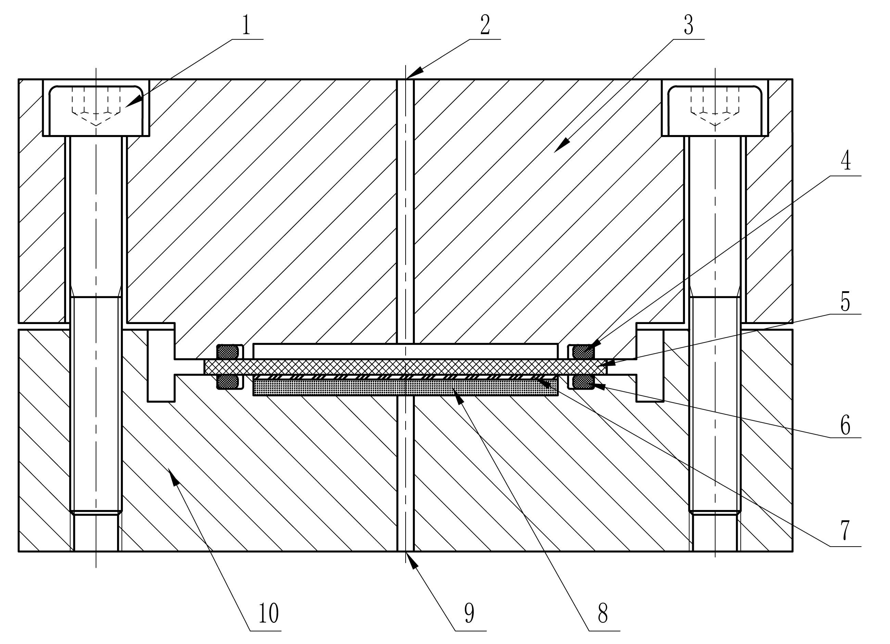
Description:
1 ——Bolt; | 6 ——Sealing Ring 2;
2 ——Gas inlet; | 7 ——Wire mesh screen;
3 ——High-pressure side cavity; | 8 ——Sintered metal support;
4 ——Sealing Ring 1; | 9 ——Hydrogen volume detection port;
5 ——Disc sample; | 10 ——Low-pressure side cavity.
Figure A.1 Basic structure of main body of hydrogen permeation test device

