ICS 27.010
F01

National Standard of the People's Republic of China

GB/T 42536—2023

Assembly valve on high pressure hydrogen storage cylinder for vehicles

Issued on 23-05-2023 Implemented on 01-06-2024
Promulgated by
State Administration for Market Regulation
Standardization Administration of the People's Republic of China
Table of Contents
Foreword I
1 Scope 1
2 Normative References 1
3 Terms and Definitions 2
4 Basic model 2
5 Technical Requirements 3
6 Test Methods and Qualification Criterions 5
7 Inspection regulations 21
8 Labeling, packaging, transportation and storage 25
9 Product qualification certificate and batch inspection quality certificate 26
Annex A (Informative) Calculation Method of Thread Shear Stress Safety Factor 27
Annex B (Informative) Performance Test Method and Qualification Criterion of Seals for Assembly valves 32
Annex C (Informative) Air Tightness Test Method (vacuum chamber method) 35

Foreword
This standard is drafted in accordance with the rules given in the GB/T 1.1-2020, Guidelines for standardization Part 1: structure and preparation of standards.
Attention is drawn to the possibility that some of the elements of this standard may be the subject of patent rights. The issuing body of this document shall not be held responsible for identifying any or all such patent rights.
This standard was proposed and prepared by National Standardization Technical Committee of Gas Cylinders (SAC/TC 31).
Drafting entities of this Standard: China Special Equipment Inspection and Research Institute, Dalian Boiler and Pressure Vessel Inspection and Testing Research Institute Co., Ltd., Zhejiang University, Weishi Energy Technology Co., Ltd., Shanghai Sunhua New Energy System Co., Ltd., Hefei General Machinery Research Institute Co., Ltd., Zhangjiagang Furui Valve Co., Ltd., Shanghai Institute of Special Equipment Inspection and Technical Research, Beijing Tianhai Industrial Co., Ltd., Ningbo Jinjiajia Valve Co., Ltd., Tehi Hydrogen Energy Testing (Baoding) Co., Ltd.
Main drafters of this Standard: Bo Ke, Gu Chunlin, Liu Yan, Wang Dongyu, Gu Chengjie, Huang Qianghua, Zhang Baoguo, Xu Ping, Jin Xin, Lu Jiajun, Xu Peng, Sun Li, Li Xiang, Li Qian, Zhao Baodi, Wang Wei, Xu Diqing, Zhang Yan, Gao Wei.

Assembly valve on high pressure hydrogen storage cylinder for vehicles
1 Scope
This document specifies the basic model, technical requirements, test methods and qualification criterion, inspection rules, marking, packaging, transportation, storage requirements, etc. of assembly valve on high pressure storage hydrogen cylinder for vehicles (hereinafter referred to as assembly valve).
This document applies to the assembly valve on high pressure hydrogen storage cylinder for vehicles, with the nominal working pressure not greater than 70 MPa, the working temperature is -40°C~85°C, fixed on the road vehicles used as fuel tanks.
The type test of the temperature-driven safety pressure relief device for high-pressure hydrogen storage cylinders used in vehicles can be carried out with reference to this document.
2 Normative References
The following documents are indispensable for the application of this document. For dated references, only the edition dated applies. For undated references, the latest edition of the referenced document (including any amendments) applies.
GB/T 192 General purpose metric screw threads—Basic profile
GB/T 196 General purpose metric screw threads—Basic dimensions
GB/T 197 General purpose metric screw threads—Tolerances
GB/T 223 Methods for Chemical Analysis of Steel and Alloys
GB/T 228.1 Metallic Materials - Tensile Testing - Part 1: Method of Test at Room Temperature
GB/T 229 Metallic materials—Charpy pendulum impact test method
GB/T 1220 Stainless steel bars
GB/T 3191 Extrusion rods and bars of aluminum and aluminum alloys
GB/T 3934 Gauges for General Purpose Screw Threads
GB/T 7762-2014 Rubber, Vulcanized or Thermoplastic - Resistance to Ozone Cracking - Static Strain Testing
GB/T 7999 Optical emission spectrometric analysis method of aluminum and aluminum alloys
GB/T 8337 Fusible plug device for gas cylinders
GB/T 11170 Stainless steel - Determination of multi-element contents - Spark discharge atomic emission spectrometric method (Routine method)
GB/T 13005 Terminology of gas cylinders
GB/T 15382 General specifications of gas cylinder valves
GB/T 20668 Unified screw threads—Basic dimensions
GB/T 20975 Methods for chemical analysis of aluminum and aluminum alloys
GB/T 32249 Aluminum and aluminum-alloy die forgings, hand forgings and rolled ring forgings—General specification
GB/T 34542.2 Storage and transportation systems for gaseous hydrogen—Part 2: Test methods for evaluating metallic material compatibility in hydrogen
GB/T 34542.3 Storage and transportation systems for gaseous hydrogen—Part 3: Test method for determination of the susceptibility of metallic materials to hydrogen gas embrittlement (HGE)
GB/T 37244 Fuel Specification for Proton Exchange Membrane Fuel Cell Vehicles - Hydrogen
YS/T 479 Aluminum and aluminum alloy forgings for general industrial use
3 Terms and Definitions
3.1 Terms and definitions
In addition to those established in GB/T 13005, the following terms and definitions are applicable to this Document.
3.1.1 Assembly valve on high pressure hydrogen storage cylinder for vehicles
A valve that consists of manual shut-off valve, automatic shut-off valve, check valve, thermally-activated pressure relief device (TPRD), temperature sensor and other components and is installed on high pressure hydrogen storage cylinder for vehicles.
3.2 Symbols
The following symbols apply to this Document.
P -- Nominal working pressure of the assembly valve.
4 Basic model
4.1 The assembly valve shall include manual shut-off valve, automatic shut-off valve, check valve, TPRD, temperature sensor and other components.
4.2 The marking of a cylinder valve model shall be composed of the following parts:
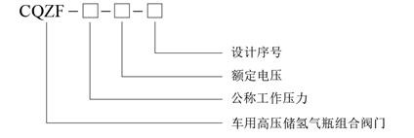
Design serial number
Rated voltage
Nominal working pressure
Assembly valve on high pressure hydrogen storage cylinder for vehicles
Example: For an assembly valve on high pressure hydrogen storage cylinder for vehicles with a nominal working pressure of 35MPa, a rated voltage of 12V and a design serial number of I, the model is marked as CQZF-35-12-I.
5 Technical Requirements
5.1 Material requirements
5.1.1 Metallic materials
5.1.1.1 The main parts and materials of assembly valves (valve, valve stem and other pressure parts) should have the original quality certificate provided by the material manufacturer, or a copy of the quality certificate with the official seal of the material business company and the signature (seal) of the person in charge.
5.1.1.2 The material of the main parts of the assembly valve should have good compatibility with hydrogen and meet the requirements of the corresponding material standards.
5.1.1.3 The main parts and components of the assembly valve should be made of 6061 aluminum alloy or S31603 austenitic stainless steel. 6061 aluminum alloy extruded rods shall comply with the provisions of GB/T 3191, and forgings shall comply with the provisions of GB/T 32249 or YS/T 479. S31603 austenitic stainless steel bars shall comply with the provisions of GB/T 1220, and forgings shall comply with the provisions of NB/T 47010. The Ni content of S31603 austenitic stainless steel should be not less than 12%, and the section shrinkage rate should not be less than 70%; for parts’ materials with a stress value greater than 25% of guaranteed value of tensile strength under 1.25 times the nominal working pressure, should also satisfy that the Ni equivalent is not less than 28.5% (Ni equivalent calculation formula is: Nig= 12.6C+ 0.35Si + 1.05Mn + Ni+0.65Cr+0.98Mo).
5.1.1.4 For assembly valves with a nominal working pressure greater than 40 MPa, if the main parts are made of materials other than 6061 aluminum alloy and S31603 austenitic stainless steel, the hydrogen compatibility test and hydrogen brittle sensitivity test shall be carried out according to the provisions of 6.1.3 and 6.1.4.
5.1.2 Non-metallic seal materials
5.1.2.1 Non-metallic seal materials should have the original quality certificate provided by the material manufacturer, or a copy of the quality certificate with the official seal of the material business company and the signature (seal) of the person in charge. The quality certificate should include the hardness, tensile strength, elongation at break, etc. of the non-metallic seal material.
5.1.2.2 Non-metallic seals should be made of materials with good compatibility with high-pressure hydrogen, and the properties of the seal materials should meet the requirements of 6.7.
5.2 Design and fabric

5.2.1 The assembly valve used on high-pressure hydrogen storage cylinders for vehicles that cannot be disassembled due to the structural design of the vehicle body has a design service life of not less than 15 years; the assembly valve used on high-pressure hydrogen storage cylinders for other vehicles has a design service life of not less than 6 years.
5.2.2 The assembly valve should have the following function:
a) One-way cut-off function, when the power is not on, hydrogen can be filled into the cylinder through the assembly valve in one direction, and at the same time, the gas in the cylinder can be prevented from flowing out in reverse;
b) Safety pressure relief function, in special cases such as fire, the gas in the cylinder can be automatically released through the assembly valve TPRD;
c) Temperature monitoring function, which can monitor the gas temperature inside the cylinder;
d) Manual opening and closing function, the valve can be opened or closed by manual operation;
e) Automatic opening and closing function, the valve can be opened or closed by electric signal.
5.2.3 Assembly valve should carry out finite element stress analysis. Under 2.5 times the nominal working pressure, the stress of each part of the valve should not be greater than the guaranteed value of the yield strength of the valve material.
5.2.4 The thread specifications of the inlet and outlet ports of assembly valves shall adopt straight threads in accordance with GB/T 192, GB/T 196, GB/T 197 or GB/T 20668, or other threads in accordance with the corresponding standards.
5.2.5 The assembly valve thread should be checked for strength, and the shear stress safety factor of the thread at 1.5 times the nominal working pressure should not be less than 4. The calculation method of thread shear stress safety factor shall be carried out in accordance with Annex A.
5.2.6 Fusible alloys or glass bubbles should be used for safety pressure relief devices, and the operating temperature is (110±5) ℃. Fusible alloys and glass bubbles should comply with the standards for safety pressure relief devices for gas cylinders. The safety pressure relief channel of the assembly valve should be independent and should not be connected with other functional channels. Only one safety pressure relief device can be installed on each safety pressure relief channel.
5.2.7 The valve should be forged and formed, and there should be no defects such as cracks, wrinkles, inclusions, looseness, and shrinkage cavities.
5.2.8 O-rings should be tested according to the provisions of B.3 in Annex B before selected. The compression set test, hardness change test, hydrogen damage test and temperature shrinkage test should be carried out by the O-ring manufacturer and test reports should be provided.
6 Test Methods and Qualification Criterions
6.1 Main parts metal material test
6.1.1 Mechanical properties test
6.1.1.1 Test methods
Tensile test specimens and test methods for materials of main parts and components shall be carried out in accordance with the provisions of GB/T228.1, impact test specimens and test methods shall be in accordance with GB/T 229 (except for aluminum alloy materials).
6.1.1.2 Qualification criterions
The test results shall meet the requirements of material standards and design.
6.1.2 Chemical composition analysis
6.1.2.1 Analytical method
The chemical composition analysis of 6061 aluminum alloy is carried out in accordance with GB/T7999 or GB/T20975, and the chemical composition analysis of S31603 austenitic stainless steel is carried out in accordance with GB/T223 (all parts) or GB/T11170. When other materials are used, the chemical composition analysis of them shall be carried out in accordance with the corresponding national standards.
6.1.2.2 Qualification criterions
The analytical results shall meet the requirements of material standards and design.
6.1.3 Hydrogen compatibility test
6.1.3.1 Test methods
The determination of tensile properties, fatigue properties and fracture mechanical properties of materials in hydrogen should meet the requirements of GB/T 34542.2.
6.1.3.2 Qualification criterions
The test results shall meet the requirements of material standards and design.
6.1.4 Hydrogen brittle susceptibility test
6.1.4.1 Test methods
The hydrogen brittle susceptibility test shall be carried out according to GB/T34542.3.
6.1.4.2 Qualification criterions
The test results shall meet the requirements of material standards and design.
6.2 Visual inspection
6.2.1 Test method
The appearance of valve body shall be inspected visually.
6.2.2 Qualification criterions
a) There should be no defects such as cracks, wrinkles, inclusions, looseness, shrinkage cavities, etc. on the surface of the valve;
b) The thread should be smooth, and inverted teeth, flat teeth, double lines, flat teeth bottoms, cusps, wide teeth, and obvious jumping ripples on the thread surface are not allowed.
6.3 Thread inspection
6.3.1 Test method
Check with a gauge that complies with GB/T3934 or the corresponding standard.
6.3.2 Acceptance indicators
The check results should meet the following requirements:
a) The number of effective pitches and surface roughness of the thread shall meet the design requirements;
b) The teeth profile, size and tolerance of the thread shall comply with relevant standards.
6.4 Air tightness test
6.4.1 Test method
In accordance with the provisions of Annex C, the air tightness test shall be carried out under normal temperature conditions at (2±0.5) MPa and a pressure not lower than 1.25p, and the test medium shall be pure helium. According to the structure of the assembly valve, the internal leakage and external leakage tests are carried out respectively.
6.4.2 Qualification criterions
Helium leakage rate should not exceed 7.5 mL/h.
6.5 TPRD test
6.5.1 Hydrogen cycle test
6.5.1.1 Test method
Use hydrogen to perform 15,000 pressure cycles on 5 TPRDs and the cycle frequency should not exceed 10 times/min. The test requirements are shown in Table 1.
Table 1 Hydrogen cycle test method
Cycle pressure |  | Cycle times/times | Test temperature/℃
Lower limit | Upper limit | Cycle times/times | Test temperature/℃
(2±1) MPa | 1.5p (±1MPa) | 5 | 85
(2±1) MPa | 1.25p (±1MPa) | 1495 | 85
(2±1) MPa | 1.25p (±1MPa) | 9500 | 55±5
6.5.1.2 Qualification criterions
After the hydrogen cycle test, the TPRD should meet the requirements of 6.5.9 leak test, 6.5.10 action test and 6.5.11 flow test.
6.5.2 Accelerated life test
6.5.2.1 Test method
The test steps are as follows.
a) Carry out this test on 8 TPRDs, among which the test temperature of 3 TPRDs is the operating temperature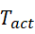, and the test temperature of the other 5 TPRDs is the accelerated life temperature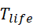, the calculation formula is as follows:
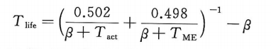
In the formula, β takes 273.15℃, 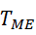 takes 85℃, takes 110℃.
b) Put the TPRD in an incubator or a water bath, and the temperature tolerance in the test is ±1°C.
c) The pressure of hydrogen or inert gas at the inlet of TPRD should not be lower than 1.25p. The pressure source can be located outside the incubator or water bath and pressurize the TPRD with a single or branch piping system. If a branch piping system is used, each branch piping shall contain a check valve.
6.5.2.2 Qualification criterions
The TPRD action time tested under should not exceed 10 h. The TPRD tested under should not act within 500 h, and the TPRD after the test should meet the requirements of 6.5.9 leak test.
6.5.3 Temperature cycle test
6.5.3.1 Test method
The test steps are as follows.
a) Put a TPRD without internal pressure in a liquid with a temperature less than or equal to -40°C for at least 2 hours, then transfer it to a liquid with a temperature greater than or equal to 85°C within 5 minutes, and let it stand at this temperature at least 2 h, after which transfer the TPRD to a liquid at a temperature less than or equal to -40 °C within 5 minutes;
b) Repeat step a) to complete 15 cycles;
c) Put the TPRD in a liquid with a temperature less than or equal to -40 °C for at least 2 hours, and then use hydrogen to perform 100 pressure cycles on the TPRD at an ambient temperature less than or equal to -40 °C. The lower limit of the pressure cycle should not exceed 2 MPa, and the upper limit of the pressure cycle should not be less than 0.8p.
6.5.3.2 Qualification criterions
After the temperature cycle test, the TPRD shall meet the requirements of 6.5.9 leakage test, 6.5.10 action test and 6.5.11 flow test, wherein the temperatures of the leak test shall not be higher than -40°C.
6.5.4 Salt spray corrosion resistance test
6.5.4.1 Test method
The test requirements are as follows.
a) Conduct salt spray test on 3 TPRDs. Before the test, the corresponding ports of TPRDs should be blocked according to the operating conditions. This test is a total of 100 cycles. A cycle includes a normal environment stage, a humid stage and a dry stage, and the single cycle time is 24h. The test process is shown in Figure 1.
b) In the normal environment stage, the temperature of the environmental chamber should be controlled at (25±3)°C and the relative humidity should be (45±10)%. The test time is 8h ± 10min. Salt spray is only applied to TPRD in the normal environment stage, and the first salt spray is applied at the beginning of the normal environment stage, and a total of 4 times are required. The time interval between applying salt spray is about 90min. Each time salt spray is applied, the surface of TPRD should be wetted and water droplets should be formed. The amount of spray should be sufficient to wash away traces of salt remaining on the TPRD.
c) In the humid stage, the temperature of the control environment chamber is (49 ± 2) °C, the relative humidity is 100%, and the test time is 7h ± 10min.
d) In the drying stage, the temperature of the control environment chamber is (60±2) °C and the relative humidity is not more than 30%, and the test time is 5h±10min.
e) The transition time from the normal environment stage to the humid stage should be 1 h ± 5 min, and the transition time from the humid stage to the dry stage should be 3 h ± 10 min.
f) When the test needs to be suspended due to special reasons such as weekends or holidays, it should be suspended after a test cycle is completed. During the suspension period, the temperature of the test chamber should be kept within the range of (25±3)°C, and the relative humidity should be within the range of (45±10)%.
g) After the cyclic corrosion test, rinse the TPRD with clean water, and evaluate it after it dried.
h) In the test, the environmental chamber should meet the requirements of GB/T13893.2, and the test water should meet the requirements of the third-grade water specified in GB/T6682.
When sprays the saline solution, avoid direct impact of the spray on the TPRD.
i) The mass fraction requirements of each component of the mixed saline solution are as follows:
1) Sodium chloride (NaCl): 0.9%;
2) Calcium chloride (CaCl₂): 0.1%;
3) Sodium bicarbonate (NaHCO₃): 0.075%.
Sodium chloride should be reagent grade or food grade. Calcium chloride should be reagent grade. Sodium bicarbonate should be reagent grade or food grade. The water used for preparing the solution should meet the requirements of the third-grade water specified in GB/T6682.
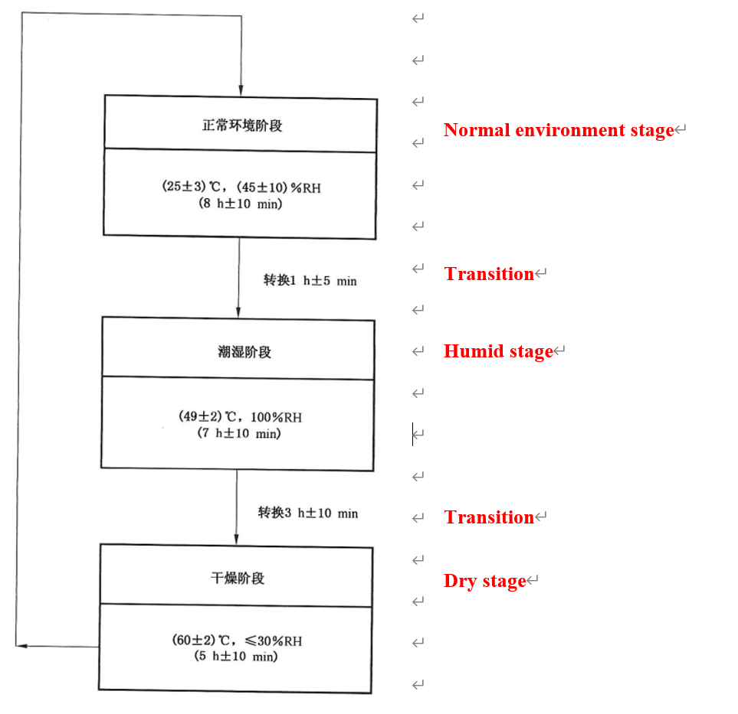
Figure 1 TPRD salt spray test flow chart
6.5.4.2 Qualification criterions
After the salt spray corrosion resistance test, the TPRD shall meet the requirements of 6.5.9 leakage test, 6.5.10 action test and 6.5.11 flow test, wherein the temperatures of the leak test shall not be higher than -40°C.
6.5.5 Condensation corrosion resistance test
6.5.5.1 Test method
The test steps are as follows.
a) Block the air inlet and outlet of TPRD, and soak TPRD in the following solutions for 24 h at room temperature:
1) Aqueous sulfuric acid solution (battery acid) with a volume fraction of 19%;
2) Ethanol gasoline solution (E10 gasoline) with a volume fraction of 10%;
3) Aqueous methanol solution (windshield washer fluid) with a volume fraction of 50%.
b) Take 1 TPRD to complete this test. After soaking in each solution, wipe off the remaining solution on the TPRD and rinse it with water. Safety precautions should be taken during the test to prevent accidents such as fires.
6.5.5.2 Qualification criterions
After the test, the TPRD should not have physical damages such as cracks, softening, swelling, etc. which affect its function (excluding dents, surface discoloration). At the same time, TPRD should meet the requirements of 6.5.9 leak test, 6.5.10 action test and 6.5.11 flow test.
6.5.6 Stress corrosion resistance test
6.5.6.1 Test method
When TPRD contains copper alloy (such as brass) parts exposed to the external environment, one TPRD should be taken for testing. The test requirements are as follows:
a) Remove grease from copper alloy parts;
b) Prepare a desiccating dish, inject ammonia water (0.9g/mL) with a volume of 2% of its volume into the desiccating dish;
c) Put TPRD on a tray that does not react with ammonia water at (35±5) mm above the ammonia water level, and seal the drying dish;
d) Put the sealed desiccator containing TPRD in the environmental chamber for 10 days, and the temperature of the environmental chamber is (35±5)℃.
6.5.6.2 Qualification criterions
No cracks or delaminating should occur.
6.5.7 Drop test
6.5.7.1 Test methods
One or six TPRDs were dropped freely from a height of 2 m onto a smooth concrete floor at room temperature. There are 6 directions of dropping (positive and negative directions of 3 orthogonal axes), and you can choose 1 TPRD to be dropped in 6 directions or each of 6 TPRDs to be dropped in one direction.
6.5.7.2 Qualification criterions
There should be no visible external damage affecting the normal use of the TPRD. Any TPRD that cannot be installed due to thread damage due to drop should not be subjected to the 6.5.8 vibration resistance test, but this drop test should not be considered a failure.
6.5.8 Vibration resistance test
6.5.8.1 Test methods
Install the TPRD (including 1 untested TPRD and 1 or 6 TPRDs that have been dropped) on a special device, and vibrate for 2 hours at the resonant frequency along the three orthogonal axes. Carry out a 10min sinusoidal frequency sweep with an acceleration of 1.5g, the frequency range is 10Hz~500Hz, and determine the resonant frequency of TPRD. If no resonant frequency is found, the test is carried on at a frequency of 40Hz.
6.5.8.2 Qualification criterions
After the test, the TPRD should meet the requirements of 6.5.9 leak test, 6.5.10 action test and 6.5.11 flow test.
6.5.9 Leak test
6.5.9.1 Test method
One untested TPRD was subjected to leak test at room temperature, high temperature and low temperature in sequence. Before starting the test, let the TPRD stand at a specified temperature and a pressure not lower than 2 MPa for at least 1 h until the temperature stabilizes. When pressurizing the TPRD, hydrogen should be used to pressurize from the inlet port. The test conditions are as follows:
a) Normal temperature: at normal temperature and (2±0.5) MPa, at a test pressure not lower than 1.25p;
b) High temperature: at a temperature not lower than 85°C and (2±0.5) MPa, at a test pressure not lower than 1.25p;
c) Low temperature: at a test pressure not higher than -40°C and (2±0.5) MPa, at a test pressure not lower than p.
Under each specified temperature and pressure condition, soak TPRD in the liquid of corresponding temperature for 1 min for observation.
6.5.9.2 Qualification criterions
If no air bubbles are generated within the specified test time, the TPRD passes the test; if air bubbles are detected, an appropriate method shall be used to measure the leakage rate. The hydrogen leakage rate should not exceed 10 mL/h.
6.5.10 Action test
6.5.10.1 Test methods
Carry out tests on 3 TPRDs that have not been tested and 5 TPRDs that have completed other test items (one for each test in 6.5.1, 6.5.3~6.5.5, 6.5.7 and 6.5.8), and the test requirements are as follows.
a) The test device shall include an environmental chamber capable of controlling the air temperature and flow rate so that the air temperature reaches (600±10)°C. TPRD should not come into direct contact with flames. Install the TPRD on the special device, and record the test arrangement.
b) Thermocouples should be used to monitor the temperature of the environmental chamber. 2min before the start of the test, the temperature of the environmental chamber should be stabilized within the specified temperature range.
c) The TPRD should be pressurized to (2±0.5) MPa before the TPRD is put into the environmental chamber.
d) Put the pressurized TPRD into the environmental chamber until the TPRD operates, and record the operating time.
6.5.10.2 Qualification criterions
The action time difference of the three untested TPRDs should be less than or equal to 2 min, and the average action time of the above three TPRDs was used as the reference action time. The difference between the action time of the TPRD that has been tested by other tests and the reference action time should be less than or equal to 2 min.
6.5.11 Flow test
6.5.11.1 Test methods
The test requirements are as follows:
a) Carry out flow tests on 8 TPRDs, of which 3 TPRDs have not been tested, and 5 TPRDs have been tested respectively according to the provisions of 6.5.1, 6.5.3~6.5.5, 6.5.7 and 6.5.8 ( 1 for each trial);
b) Conduct an action test for each TPRD in accordance with the provisions of 6.5.10. After the TPRD operates, use hydrogen, air or inert gas to conduct a flow test for each TPRD without cleaning, removing parts or repairing;
c) The air inlet pressure should be (2±0.5) MPa, the air outlet pressure should be atmospheric pressure, record the air inlet pressure and temperature;
d) The measurement accuracy of the flow rate should be ±2%.
6.5.11.2 Qualification criterions
The minimum value of the eight TPRDs measured flows should be greater than or equal to 90% of the maximum value.
6.6 Check valve and manual/automatic shut-off valve test e
6.6.1 Pressure resistance test
6.6.1.1 Test methods
Carry out this test on an untested valve firstly, and use its burst pressure as the benchmark burst pressure of the valve. The test requirements are as follows:
a) Block the air outlet of the valve and make the inside of the valve in a connected state;
b) Use non-corrosive liquid to slowly apply a hydraulic pressure of not less than 2.5p to the air inlet of the valve, keep the pressure for 3 minutes, and then check the valve;
c) Continue to pressurize at a pressure increase rate less than or equal to 1.4MPa/s until the valve fails, and record the pressure when the valve fails.
6.6.1.2 Qualification criterions
After holding the pressure for 3min, the valve should not rupture. For valves that have undergone other tests, the measured burst pressure should not be less than 0.8 times the reference burst pressure, or greater than 4 times the nominal working pressure p.
6.6.2 Leak test
6.6.2.1 Test methods
One untested valve is subjected to leak test under normal temperature, high temperature and low temperature conditions. Before starting the test, keep the valve at the specified temperature and pressure not lower than 2 MPa for at least 1 h until the temperature stabilizes. When pressurizing the valve, the outlet of the valve should be blocked, and hydrogen should be used to pressurize from the inlet of the valve. The test conditions are as follows:
a) Normal temperature: at normal temperature and (2±0.5) MPa, the test pressure is not less than 1.25p;
b) High temperature: at a temperature not lower than 85°C and (2±0.5) MPa, the test pressure is not less than 1.25p;
c) Low temperature: at a temperature not higher than -40°C and (2±0.5) MPa, the test pressure is not less than p.
Under each specified temperature and pressure condition, immerse the valve in the corresponding temperature liquid for 1min for observation.
6.6.2.2 Qualification criterions
If no air bubbles are generated within the specified test time, the valve passes the test; if air bubbles are detected, the leakage rate shall be measured by an appropriate method. The hydrogen leakage rate should not exceed 10 mL/h.
6.6.3 Extreme temperature and pressure cycle test
6.6.3.1 Test methods
The number of cycles of the check valve is 15000 times, the number of cycles of the automatic shut-off valve is 50000 times, and the number of cycles of the manual shut-off valve is 100 times. The test procedure is as follows.
a) Install the valve on a special device. Under the specified pressure, the valve is continuously cycled with hydrogen. The definition of a cycle is as follows:
1) For the check valve, install it on the special device for the test, close the outlet of the valve, and fill the inlet of the valve with hydrogen to the specified test pressure within 6 pressurization steps. Then release the pressure from the air inlet of the valve, and before the next cycle, the pressure at the air outlet of the check valve should be less than 0.6p.
2) For the shut-off valve, install it on the special device for the test, and continuously pressurize its inlet and outlet.
3) One cycle should include one operation stated above and one reset.
b) Carry out the following test on 1 valve:
1) Normal temperature cycle. The test pressure should not be lower than p, the number of cycles should be 90% of the total number of cycles, and the test temperature should be normal temperature.
2) High temperature cycle. The test pressure should not be lower than 1.25p, the number of cycles should be 5% of the total number of cycles, and the test temperature should be greater than or equal to 85 °C.
3) Low temperature cycle. The test pressure shall not be lower than 0.8p, the number of cycles shall be 5% of the total number of cycles, and the test temperature shall be less than or equal to -40 °C.
c) Vibration test. After the cycle test is completed, the check valve and the automatic shut-off valve with check valve function shall be subjected to a 24 h vibration test at a hydrogen flow rate that can cause the maximum vibration of the valve disc.
6.6.3.2 Qualification criterions
After the test, the valve should meet the requirements of 6.6.2 leak test and 6.6.1 pressure resistance test.
6.6.4 Salt spray corrosion resistance test
6.6.4.1 Test method
a) Carry out salt spray test on 3 valves. Before the test, the corresponding ports of the valves should be blocked according to the operating conditions. The test is a cycle test, a total of 100 cycles. A single cycle includes a normal environment stage, a humid stage and a dry stage, and the single cycle time is 24 h. The test process is shown in Figure 2.
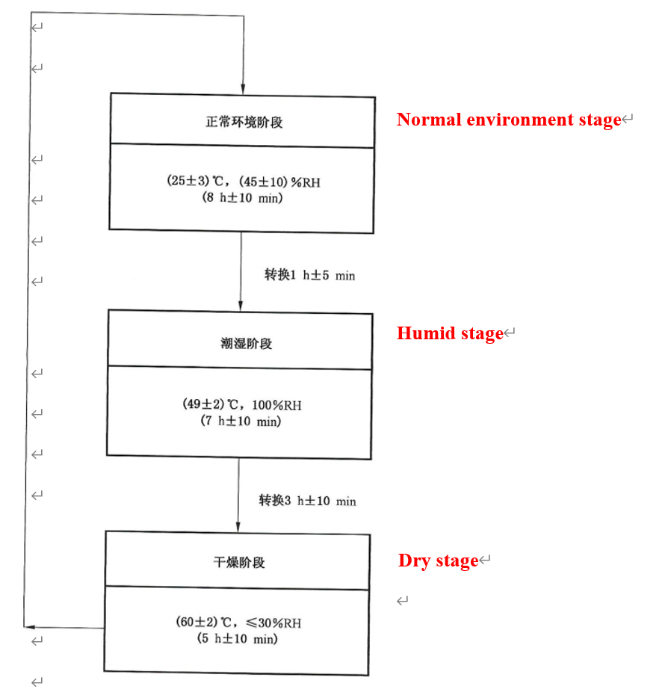
Figure 2 Check valve and shut-off valve salt spray test flow chart
b) In the normal environment stage, the temperature of the environmental chamber should be controlled at (25±3)°C and the relative humidity should be (45±10)%. The test time is 8h ± 10min. Salt spray is only applied to valves in the normal environment stage, and the first salt spray is applied at the beginning of the normal environment stage, and a total of 4 times are required. The time interval between applying salt spray is about 90min. Each time salt spray is applied, the surface of valves should be wetted and water droplets should be formed. The amount of spray should be sufficient to wash away traces of salt remaining on the valves.
c) In the humid stage, the temperature of the control environment chamber is (49 ± 2) °C, the relative humidity is 100%, and the test time is 7h ± 10min.
d) In the drying stage, the temperature of the control environment chamber is (60±2) °C and the relative humidity is not more than 30%, and the test time is 5h±10min.
e) The transition time from the normal environment stage to the humid stage should be 1 h ± 5 min, and the transition time from the humid stage to the dry stage should be 3 h ± 10 min.
f) When the test needs to be suspended due to special reasons such as weekends or holidays, it should be suspended after a test cycle is completed. During the suspension period, the temperature of the test chamber should be kept within the range of (25±3)°C, and the relative humidity should be within the range of (45±10)%.
g) After the cyclic corrosion test, rinse the VALVES with clean water, and evaluate it after it dried.
h) In the test, the environmental chamber should meet the requirements of GB/T13893.2, and the test water should meet the requirements of the third-grade water specified in GB/T6682. When sprays the saline solution, avoid direct impact of the spray on the VALVES.
i) The mass fraction requirements of each component of the mixed saline solution are as follows:
1) Sodium chloride (NaCl): 0.9%;
2) Calcium chloride (CaCl₂): 0.1%;
3) Sodium bicarbonate (NaHCO₃): 0.075%.
Sodium chloride should be reagent grade or food grade. Calcium chloride should be reagent grade. Sodium bicarbonate should be reagent grade or food grade. The water used for preparing the solution should meet the requirements of the third-grade water specified in GB/T6682.
6.6.4.2 Qualification criterions
After the salt spray corrosion resistance test, the valves shall meet the requirements of 6.6.2 leakage test, and 6.6.1 pressure resistance test.
6.6.5 Condensation corrosion resistance test
6.6.5.1 Test methods
The test steps are as follows.
a) Block the air inlet and outlet of the valve, and soak the valve in the following solutions for 24 hours at room temperature:
1) Sulfuric acid aqueous solution (battery acid) with a volume fraction of 19%;
2) Ethanol gasoline solution (E10 gasoline) with a volume fraction of 10%;
3) Aqueous methanol solution with a volume fraction of 50% (windshield washer fluid).
b) Use 1 valve to complete this test. After soaking in each solution, the residual solution on the valve should be wiped off and rinsed with water. Safety precautions should be taken during the test to prevent accidents such as fires.
6.6.5.2 Qualification criterions
The valve under test should not have physical damages such as cracks, softening, swelling, etc. which affect its function (excluding dents, surface discoloration). At the same time, the valve should meet the requirements of 6.6.2 leak test and 6.6.1 pressure resistance test.
6.6.6 Electrical test
6.6.6.1 Test methods
Carry out the test with one automatic shut-off valve, and the test shall meet the following requirements at the same time.
a) Abnormal voltage test. Connect the solenoid valve to the variable voltage DC power supply, and perform the following operations on it:
1) Stable (constant temperature) at 1.5 times the rated voltage for at least 1 h;
2) Increase the voltage to the lesser value of 2 times the rated voltage or 60 V for at least 1 min.
b) Minimum opening voltage test. Pressurize the valve to nominal working pressure. For 12 V system valves, apply a voltage not greater than 9 V; for 24 V system valves, apply a voltage not greater than 18 V; for other voltage system valves, apply a voltage not greater than 75% of the equivalent voltage.
c) Insulation resistance test. Apply 1000 V DC between the power supply and the valve shell for at least 2 s.
6.6.6.2 Qualification criterions
The test results should meet the following requirements:
a) For the abnormal voltage test, there should be no dangerous situations such as smoke, melting or fire during the test, and the valve should open normally after the test, and it should meet the requirements of 6.6.2 leak test;
b) For the minimum opening voltage test, the valve should open normally after voltage is applied;
c) For the insulation resistance test, the insulation resistance value of the valve should be greater than or equal to 240kΩ.
6.6.7 Vibration resistance test
6.6.7.1 Test methods
Install an untested valve on a special device, block the gas outlet, and fill the inlet of the valve with hydrogen, helium or nitrogen-hydrogen mixture (hydrogen concentration should not be less than 5%) to the nominal working pressure p , and vibrate at the resonant frequency for 2 h along the three orthogonal axis directions. Carry out a 10min sinusoidal frequency sweep with an acceleration of 1.5g, the frequency range is 10Hz~500Hz, and determine the resonant frequency of the valve. If no resonant frequency is found, the test is carried out at a frequency of 40 Hz.
6.6.7.2 Qualification criterions
No visible external damage and the valve should meet the requirements of 6.6.2 leak test and
6.6.8 Stress corrosion cracking test
6.6.8.1 Test methods
When the valve contains copper alloy (such as brass) parts exposed to the external environment, one valve should be taken for this test. The test requirements are as follows:
a) Disassemble the valve, remove the grease on the copper alloy parts, and then reassemble it;
b) Prepare a desiccator jar, inject 0.9 g/mL ammonia water 2% of its volume into it;
c) Place the valve on a tray that does not react with ammonia water at (35±5) mm above the ammonia water level, and seal the desiccator jar;
d) The sealed desiccator jar equipped with a valve was placed in an environmental chamber for 10 days, and the temperature of the environmental chamber was (35±5) °C.
6.6.8.2 Qualification criterions
There should be no cracking or delaminating.
6.6.9 Pre-cooled hydrogen exposing test
6.6.9.1 Test methods
Test on 1 valve. The test steps are as follows:
a) Fill the valve with pre-cooled hydrogen at a flow rate of 30 g/s at room temperature, and the temperature is less than or equal to -40 °C for at least 3 minutes, then stop for 2 minutes, repeat the above operation 10 times;
b) Fill the valve with pre-cooled hydrogen at a flow rate of 30 g/s at room temperature, and the temperature is less than or equal to -40°C for at least 3 minutes, then stop for 15 minutes, and repeat the above operation 10 times.
6.6.9.2 Qualification criterions
After the test, the valve shall comply with the provisions of 6.6.2.1a, leak test at room temperature.
6.7 Performance test of non-metallic seals
6.7.1 Oxygen aging resistance test
6.7.1.1 Test methods
Put 3 non-metallic seals in oxygen (purity ≥ 99.5%) at a temperature of (70±2) ℃ and a test pressure of 2 MPa for 96 h.
6.7.1.2 Qualification criterions
No cracks or other visible defects.
6.7.2 Ozone compatibility test
6.7.2.1 Test methods
Test the 3 samples according to method A in GB/T 7762-2014. The sample should be a wide sample, the tensile strain of the sample is 20%, and exposed in air of the ambient temperature of 40 ° C, the ozone concentration of (50 ±5) ×10⁻⁸for 120 h.
6.7.2.2 Qualification criterions
There were no cracks or obvious signs of deterioration on the surface of the samples.
6.7.3 Hydrogen compatibility test
6.7.3.1 Test methods
The test steps are as follows:
a) Measure the volume of the three non-metallic seals and weigh them;
b) Put the seal in hydrogen at the nominal working pressure of the valve and at a temperature of 15 °C for 168 h, then reduce the pressure to atmospheric pressure within 10 s;
c) Put the seal in hydrogen at the nominal working pressure of the valve and at a temperature of -40°C for 168 h, then reduce the pressure to atmospheric pressure within 10 s;
d) Take out the seal and immediately measure its volume change rate and mass change rate.
6.7.3.2 Qualification criterions
The seal should have no abnormal phenomena such as damage, its volume expansion rate should not exceed 25% or volume shrinkage rate should not exceed 1%, and the mass change rate should not exceed 10%.
6.8 Temperature sensor test
6.8.1 Test methods
Put the temperature sensor to be tested and the verified second-class standard platinum resistance thermometer in a normal temperature environment at the same time. For temperature sensors in the form of thermocouples and semiconductors, turn on the power supply according to their rated working voltage, measure their feedback voltage or feedback current, and then look up the table or calculate their corresponding temperature values; for temperature sensors in the form of resistance, measure their resistance value, and then look up the table or calculate its corresponding temperature value.
6.8.2 Qualification criterions
Compare the measured value of the temperature sensor with the indicated value of the verified second-class standard platinum resistance thermometer, the error should meet the design requirements.
7 Inspection regulations
7.1 Material inspection
7.1.1 The mechanical properties of the metal raw materials shall be retested according to the batch, and the chemical composition shall be retested according to the furnace number, which shall comply with the provisions of 6.1.1 and 6.1.2.
7.1.2 O-rings should be visually inspected one by one, and should meet the requirements of B.3.1. Other non-metallic seals should be visually inspected one by one, and the appearance should be intact and free of defects.
7.1.3 O-rings shall be subjected to dimensional inspection and oxygen aging resistance test in batches, and shall comply with the provisions of B.3.2 and 6.7.1.
7.2 Product release inspection
7.2.1 One-by-one inspection
Assembly valves shall be inspected one by one before releasing from the factory, and the inspection items shall be in accordance with the provisions in Table 2. During the inspection process, if there is an unqualified item, the valve is unqualified.
7.2.2 Batch inspection
The manufacturer shall determine the batch of assembly valves, and the maximum batch shall not exceed 200. Assembly valves for batch inspection shall be selected from the products that pass the one-by-one inspection, and 2 pieces shall be selected for each batch. The inspection items shall be in accordance with the provisions in Table 2. During the inspection process, if one combination valve does not meet the requirements, double the sampling; if there are still unqualified valves during the re-inspection, this batch of valves is unqualified.
Table 2 Factory Inspection Items
Inspection items | Release inspection |  | Test methods and Qualification criterions
Inspection items | One-by-one inspection | Batch inspection | Test methods and Qualification criterions
Visual inspection | √ |  | 6.2
Thread inspection |  | √ | 6.3
Air tightness test | √ | √ª | 6.4
Electrical test | √^{b} |  | 6.6.6
Temperature sensor test | √ |  | 6.8
For one-by-one inspection, the electrical test does not include the abnormal voltage test.
7.3 Type test
7.3.1 Assembly valves that have one of the following conditions should be type tested by an inspection agency that has obtained the corresponding valve type test qualification:
a) Before launching new products;
b) There are major changes in the material, structure type, process, etc. of the product that affect the safety performance;
c) Clearly stipulated by relevant safety technical specifications.
7.3.2 The assembly valves for type test shall be selected from the products that have passed the factory product release inspection. The test items are shown in Table 3, and the test sequence and number of test pieces for the type test are shown in Figure 3 and Figure 4.All items of the type test shall comply with the requirements of this document. If any test result of a certain valve does not meet the requirements of this document, the valve shall be judged as unqualified for the type test. If it is caused by design reasons, the manufacturing body shall change the design, carry out trial production according to the changed design, and re-take samples for type tests of all items; if it is caused by improper process or manufacturing control, the manufacturing body shall report to the type test institution and submit a written explanation to solve the problem, and after the confirmation of the type test institution, the sample can be re-manufactured and re-taken by the type test institution to re-test the relevant items.
Table 3 List of type test items
Subject | Test items | Test methods and criterions
Valve main parts metal material test | Mechanical properties test | 6.1.1
Valve main parts metal material test | Chemical composition analysis | 6.1.2
Non-metallic seals | Oxygen aging resistance test | 6.7.1
Non-metallic seals | Ozone compatibility test | 6.7.2
Non-metallic seals | Hydrogen compatibility test | 6.7.3
Assembly valves | Visual inspection | 6.2
Assembly valves | Thread inspection | 6.2
TPRDs | Hydrogen cycle test | 6.5.1
TPRDs | Accelerated life test | 6.5.2
TPRDs | Temperature cycle test | 6.5.3
TPRDs | Salt spray corrosion resistance test | 6.5.4
TPRDs | Condensation corrosion resistance test | 6.5.5
TPRDs | Stress corrosion resistance test  (copper alloy parts only) | 6.5.6
TPRDs | Drop test | 6.5.7
TPRDs | Vibration resistance test | 6.5.8
TPRDs | Leak test ^{a, f} | 6.5.9
TPRDs | Action test ª | 6.5.10
TPRDs | Flow test ª | 6.5.11
Check valves and shut-off valves | Pressure resistance test ^{a, b, c, d, e, f} | 6.6.1
Check valves and shut-off valves | Leak test ^{c, d} | 6.6.2
Check valves and shut-off valves | Extreme temperature and pressure cycle test | 6.6.3
Check valves and shut-off valves | Salt spray corrosion resistance test | 6.6.4
Check valves and shut-off valves | Condensation corrosion resistance test | 6.6.5
Check valves and shut-off valves | Electrical test ^{g} | 6.6.6
Check valves and shut-off valves | Vibration resistance test ^{c} | 6.6.7
Check valves and shut-off valves | Stress corrosion cracking test  (copper alloy parts only) | 6.6.8
Check valves and shut-off valves | Pre-cooled hydrogen exposing test  (p>35MPa valves only) | 6.6.9
a) The TPRD used for the assembly valve shall be installed on the assembly valve during the TPRD type test; but when the end plug with TPRD and the assembly valve with TPRD has passed the type test use the same material, structure type, component geometry and minimum discharge diameter, this test shall be carried out.
b) When the structural type of TPRD on the assembly valve changes (for example, fusible plug is changed to glass bulb or vice versa), this test should be added in addition to all test items of TPRD; For changes in the minimum bleed path, the end plug with TPRD (using the same material, structure type, component geometric size and minimum discharge diameter as the combined valve) conducts all TPRD tests.
c) This test shall be carried out when the assembly valve only has external dimensions, and the connection mode and specifications of the gas filling port, gas outlet port and pressure sensor (to measure the pressure in the cylinder) interface are changed.
d) This test shall be carried out when only the inlet thread specification of the assembly valve is changed.
e) For newly designed end plugs with TPRD, this test shall be carried out in addition to all test items of TPRD.
f) This test shall be carried out when only the inlet thread specification and external dimensions of the end plug with TPRD are changed.
g) When carrying out the type test, the electrical test should be completed in sequence according to 6.6.6 a), b) and c) with the same assembly valve.
8 Labeling, packaging, transportation and storage
8.1 Labeling
      - The assembly valve shall have the following permanent and clear marks:
      - Valve model;
      - The nominal working pressure of the valve;
      - The opening and closing direction of the manual shut-off valve;
      - Manufacturer's name or trademark;
      - The operating temperature and discharge path of the safety pressure relief device;
      - Production date and batch number;
      - The document number;
      - Electronic read tags;
      - Product number;
      - Design service life;
      - Solenoid valve rated voltage.
8.2 Packaging, transportation and storage
8.2.1 The moisture remaining in the valve should be removed before packaging, and the valve should be kept clean, free of oil and corrosion, and the threads of the air inlet and outlet should not be damaged during packaging.
8.2.2 The product qualification certificate and instruction manual should be attached inside the packing box, and the product name, manufacturing license number, number of this document executed, production date, quantity, quality, manufacturer name and contact address, telephone number, etc. should be marked on the outside of the packing box.
8.2.3 The valve should be placed in a ventilated, dry and clean room to prevent moisture and chemical corrosion. When transporting and loading and unloading, it should be handled with care to prevent heavy pressure, collision and drop.
9 Product qualification certificate and batch inspection quality certificate
9.1 Product qualification certificate
Product qualification certificate for product released from factory shall at least contain the following contents:
a) Certificate number;
b) The name and model of the valve;
c) Nominal working pressure and nominal diameter;
d) Applicable temperature and medium;
e) Number of this document executed by the product;
f) Product release inspection date;
g) Manufacturer's name;
9.2 Batch inspection quality certificate
9.2.1 Products released in batches shall have batch inspection quality certificate
9.2.2 The content of the batch inspection quality certificate shall include the product release inspection items, product batch number and product quantity specified in this document.
9.2.3 The batch inspection quality certificate shall be valid with the signature (seal) of the responsible product quality inspector or quality assurance engineer authorized by the top management of the manufacturer.

Annex A
(Informative)
Calculation Method of Thread Shear Stress Safety Factor
A.1 Calculation formula
The thread shear stress safety factor is the ratio of the material shear strength (τm) to the thread shear stress. The shear strength (rm) of the material is taken as 0.6 times the tensile strength of the material. See formula (A.1) and formula (A.2) for thread shear stress calculation:
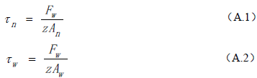
Of the formula:
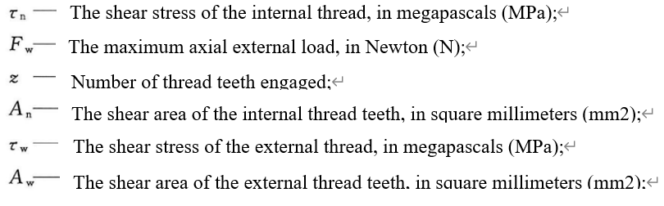
τ_{n} ——Shear stress of internal thread, expressed in MPa;
F_{w} ——Maximum axial outward load, expressed in N;
z ——The number of meshed thread teeth;
A_{n} —Sheared area of internal thread teeth, expressed in square millimeter (mm²);
τ_{w} ——Shear stress of external thread, expressed in MPa;
A_{w} —Sheared area of external thread teeth, expressed in square millimeter (mm²);
See formula (A.3) for the maximum axial external load:
Fw = p_{n}A (A.3)
Of the formula:
P_{n} ——1.5 times nominal working pressure, expressed in (MPa);
A —The pressure-bearing area of ​​the internal thread opening (take the major diameter of the internal thread), in square millimeters (mm2).
See formula (A.4) and formula (A.5) for the shear area of ​​the internal thread teeth:
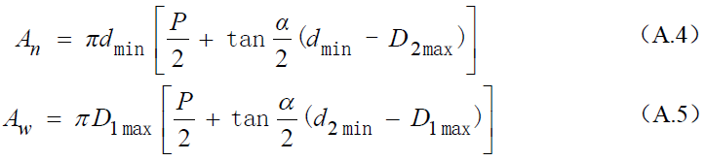
d_{min} ——The minimum major diameter of the external thread, in millimeters (mm);
P —— The pitch of the thread, in millimeters (mm) (mm);
α —— Thread angle, in degrees (°);
D_{2 max}——The maximum medium diameter of the internal thread, in millimeters (mm);
D_{1 max}——The maximum minor diameter of the internal thread, in millimeters (mm);
d_{2 min}——The minimum medium diameter of the external thread, in millimeters (mm);
See Figure A.1 for the meshing conditions and calculation taking values ​​of internal and external threads, and the following relational formulas are established, see formula (A.6) and formula (A.7):
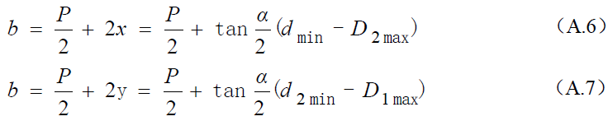
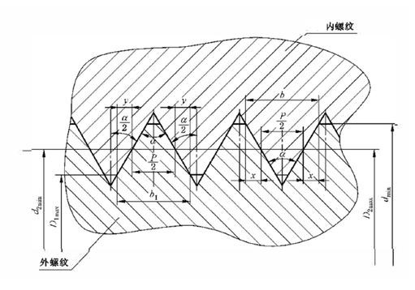
Internal thread
External thread
Figure A.1 Schematic diagram of meshing dimensions and force-bearing parts of internal and external threads
A.2 Calculation example
The guaranteed tensile strength value of the thread material is 290 MPa, the nominal working pressure is 35 MPa, the external thread is 2-12UN, and there are 14 effective thread teeth. Calculate the safety factor of thread shear stress under 1.5 times the nominal working pressure of the assembly valve.
Solution: According to the thread standard, the thread angle of 2-12N is 60°, and the extreme size of 2B internal thread is shown in Table A.1.
Table A.1 Extreme size of 2-12UN-2B internal thread
Unit: mm
Nominal diameter  D | Pitch  P | Major diameter | Medium diameter |  | Minor diameter
Nominal diameter  D | Pitch  P | D_{min} | D_{2max} | D_{2min} | D_{1max} | D_{1min}
50.8 | 2.116 | 50.8 | 49.6265 | 49.4259 | 48.9712 | 48.5140
The corresponding extreme size of 2A external thread is shown in Table A.2.

Table A.2 Extreme size of 2-12UN-2A external thread
Unit: mm
Nominal diameter  d | Thread pitch  P | Major diameter |  | Medium diameter |  | Minor diameter
Nominal diameter  d | Thread pitch  P | d_{max} | d_{min} | d_{2max} | d_{2min} | d_{1max}
50.8 | 2.116 | 50.7543 | 50.4647 | 49.3801 | 49.2252 | 48.2346
The calculation of the shear area An of ​​the teeth of the internal thread, see the formula (A. 8):
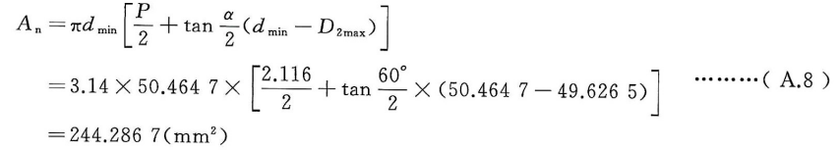
The calculation of the shear area Aw of ​​the teeth of the external thread, see the formula (A. 9):
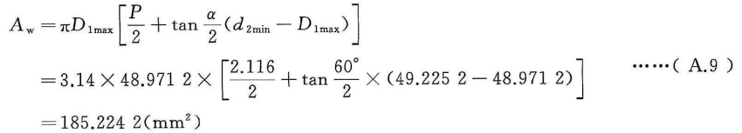
The calculation of the maximum axial external load, see the formula (A. 10):
The calculation of the shear stresses τn of internal thread, see the formula (A. 11):
The calculation of the shear stresses τw of external thread, see the formula (A. 12):
The calculation of the thread shear stress safety factor, see the formula (A. 13), formula (A. 14):
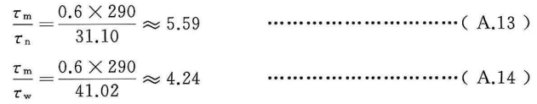
In summary, 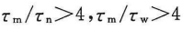, the calculated value satisfies the thread design requirements of assembly valves.

Annex B
(Informative)
Performance Test Method and Qualification Criterion of Seals for Assembly valves
B.1 General
This annex specifies the test methods for the performance of seals for assembly valves, including tensile tests for seal materials and O-ring tests.
B.2 Tensile tests for seal materials
B.2.1 Test methods
The tensile test of the seal material shall comply with the provisions of GB/T528.
B.2.2 Qualification criterions
Tensile strength and elongation at break should meet the design requirements.
B.3 O-ring tests
B.3.1 Visual inspection
B.3.1.1 Test methods
According to the test method of GB/T 3452.2, check the appearance quality of the O-ring.
B.3.1.2 Qualification criterions
The appearance quality should meet the design requirements.
B.3.2 Size inspection
B.3.2.1 Test methods
According to the test method of GB/T2941, carry out the non-contact measurement of the size of the O-ring.
B.3.2.2 Qualification criterions
O-Ring section diameter and internal diameter should meet the design requirements.
B.3.3 Hardness inspection
B.3.3.1 Test methods
According to the test method of GB/T6031, inspect the hardness of the O-ring.
B.3.3.2 Qualification criterions
The hardness should meet the design requirements.
B.3.4 Tensile test
B.3.4.1 Test methods
According to the test method of GB/T5720, carry out the tensile test on the O-ring.
B.3.4.2 Qualification criterions
Tensile strength and elongation at break should meet the design requirements.
B.3.5 Compression set test
B.3.5.1 Test methods
The cross-sectional diameter of the O-ring was determined prior to the test. Referring to the test method of GB/T3512, compress the O-ring to a specified thickness, put it in the atmosphere at a temperature of (150±2)°C for (72±1) h, restore the O-ring to its free state and measure its thickness, calculate the O-ring permanent deformation rate.
B.3.5.2 Qualification criterions
The permanent deformation rate should meet the design requirements.
B.3.6 Hardness change test
B.3.6.1 Test methods
According to the test method of GB/T 3512, the O-ring is compressed to a specified thickness, and after being put in the atmosphere at a temperature of (150 ± 2) ℃ for (72 ± 1) h, the O-ring is restored to a free state and its hardness is measured. The hardness of the O-ring before and after the test should be measured according to the provisions of GB/T 6031 and according to the size of the O-ring.
B.3.6.2 Qualification criterions
The hardness change should meet the design requirements.
B.3.7 Hydrogen damage test
B.3.7.1 Test methods
The test steps are as follows:
a) Measure the volume of 3 O-rings and weigh them;
b) Put the O-ring in hydrogen at the nominal working pressure of the cylinder at a temperature of 15 °C for 168 h, then reduce the pressure to atmospheric pressure within 10 s;
c) Put the O-ring in hydrogen at the nominal working pressure of the cylinder at a temperature of -40 °C for 168 h, then reduce the pressure to atmospheric pressure within 10 s;
d) After taking out the O-ring, immediately observe the surface of the O-ring and measure its volume change rate and mass loss rate.
B.3.7.2 Qualification criterions
The O-ring should have no abnormal phenomena such as damage, its volume expansion rate should not exceed 25% or volume shrinkage rate should not exceed 1%, and its mass loss rate should not exceed 10%.
B.3.8 Temperature shrinkage test
B.3.8.1 Test methods
According to the test method of GB/T7758, in the elongated state, cool the standard sample of the same material as the O-ring to -80℃ to solidify, remove the tensile force and increase the temperature of the sample at a uniform speed rate, and measure the temperature of the sample at which the shrinkage rate is 10%.
B.3.8.2 Qualification criterions
The temperature of the O-ring material should meet the design requirements.

Annex C
(Informative)
Air Tightness Test Method (vacuum chamber method)

C.1 Test principle and methods
C.1.1 Test principle
Connect the assembly valve with the pressurized pipeline and put it in the vacuum chamber. During the test, the assembly valve is pressurized with pure helium to the test pressure. When the assembly valve leaks, the helium enters the vacuum chamber and is sucked into the leak detector, which displays the leak rate.
C.1.2 Leak detection system
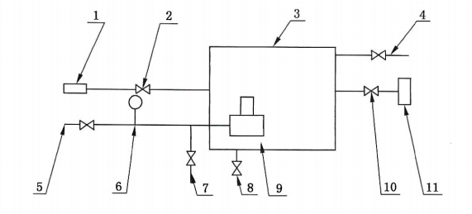
Indexing number description:
1—— Standard leak hole 7—— Exhaust pipeline
2—— Valve at the front of the leak hole 8—— Displacement gas inlet
3—— Vacuum chamber 9—— Assembly valve
4—— Displacement gas outlet 10—— Valve at the front of the leak detector
5—— Pressurized pipeline 11—— Helium mass spectrometer leak detector
6—— Pressure gauge
Figure C.1 Schematic diagram of vacuum chamber air tightness test

C.2 Test devices, equipment and instruments
Test devices, equipment and instruments should meet the following requirements.
a) The leak detector should use a helium mass spectrometer leak detector, and the helium mass spectrometer leak detector should meet the technical requirements of GB/T13979.
b) The standard leak hole should be a film helium-permeable standard leak hole, and the leak rate Q of the standard leak hole should not be greater than 1×10⁻⁷Pa·m³/s.
c) The volume of the vacuum chamber should be compatible with the size of the assembly valve, and the inner surface of the vacuum chamber should be electrochemically polished.
d) After the calibration of the leak detection system is completed, the test device should have the function of directly displaying the effective minimum detectable leak rate of the system.
e) The test device should be able to automatically, accurately and real-time display, record and save test data including time, pressure and leak rate, etc., and automatically draw time, pressure and leak rate curves according to the collected leak rate and time data. The data collection frequency of time, pressure and leak rate shall not be less than 3 times/s. All original test records stored in real time shall not be altered.
C.3 General requirement
The test process should meet the following requirements:
a) Helium mass spectrometer leak detector should adjust the working parameters of the instrument according to the instruction manual before leak detection, so that the instrument is in the best working condition;
b) During the test, the test data including time, pressure and leak rate shall be displayed, recorded and saved in real time.
C.4 Test steps
C.4.1 System connection
Connect the air tightness test system according to Figure C.1, select a vacuum chamber with a suitable volume according to the volume of the assembly valve, and install the standard leak hole near the assembly valve. Keep the standard leak hole front valve and the leak detector front valve closed.
C.4.2 System calibration
Before starting the air tightness test, the system should be calibrated as follows.
a) Open the front valve of the leak detector, start the leak detector, and open the standard leak hole until the signal of the helium mass spectrometer leak detector is stable.
b) Record the time from the opening of the standard leak hole to the stable output signal as the detection time t_{d}, and record the stable instrument reading as M₂.
c) Close the standard leak hole, and when the reading of the helium mass spectrometer leak detector is stable, record the background reading M₁.
d) The initial system sensitivity S₁ should be calculated according to formula (C.1):
Of the formula:
Q —— The leakage rate of a standard leak hole, in Pa cubic meters per second (Pa·m³/s).
e) After the calibration is completed, read the effective and minimum detectable leak rate of the system, the value should not be greater than the leak rate of the standard leak hole, and should meet M₁×S₁≤Q.
C.4.3 Helium leak test
C.4.3.1 Keep the front valve of the standard leak hole closed, start the leak detector, and record the background reading M₅ when the reading of the helium mass spectrometer leak detector is stable. When M₅×S₁≤Q, continue testing.
C.4.3.2 Use helium to pressurize the assembly valve to the test pressure, and stand still after completing the pressurization.
C.4.3.3 Start test after the standing still is completed, and record the output reading M₆ of the instrument after the detection time t_{d} is reached. If the output signal is unstable, extend the detection time until the output signal is stable.
C.4.4 Test system final calibration
After the air tightness test is completed, the final calibration of the vacuum chamber detection system should be carried out. Release the internal pressure of the assembly valve to 0MPa, keep the assembly valve in the vacuum chamber and keep the standard leak hole closed, measure the instrument reading M₃, open the standard leak hole again, the output reading of the instrument increases to M₄. Calculate the final test system sensitivity S₂ according to formula (C.2):
Of the formula:
Q —— The leakage rate of a standard leak hole, in Pa cubic meters per second (Pa·m³/s).
When M₃×S₂≤Q, the deviation between the final sensitivity S₂ and the initial sensitivity S₁ is within 35%, and the effective minimum detectable leak rate of the system is not greater than the leak rate of the standard leak hole, the test result is valid. Otherwise, perform the test again after recalibration.
C.5 Test result
After the final calibration of the detection system is qualified, the helium leakage rate Q_{He} of the assembly valve is determined by the following regulations:
a) When the output signal does not change, that is, M6=M5, it should be recorded as "below the detectable range of the system" and the test is qualified;
b) When the output signal M6 exceeds the detectable range of the system, it should be recorded as "greater than the detectable range of the system" and the test fails;
c) When the output signal M6 changes (but the output signal is within the detectable range), Q_{He} should be determined according to formula (C.3):
Of the formula:
Q —— The helium leakage rate of the assembly valve, in Pa cubic meters per second (Pa·m3/s).
注：1 Pa·m³/s=9.9 std·cm³/s=9.9 NmL/s=594 NmL/min=35640 NmL/h。

